An Intelligent Decision Support System for Material Planning and Production Process Optimization in Smart Factories
Tu-Yi Chen¹, Yi-Hong Chen², Pin-Yan Lu³, Sheng-Min Chiu^{4*}
¹Department of Computer Science and Engineering, National Sun Yat-sen University, Kaohsiung, Taiwan
²Department of Computer Science and Engineering, National Sun Yat-sen University, Kaohsiung, Taiwan
³Department of Computer Science and Engineering, National Sun Yat-sen University, Kaohsiung, Taiwan
⁴Department of Computer Science and Engineering, National Sun Yat-sen University, Kaohsiung, Taiwan
*smchiu@cse.nsysu.edu.tw

Keywords: Intelligent Decision Support System, Machine Learning, Demand Forecasting, Bottleneck Detection, Smart Manufacturing

Abstract
Effective inventory management and production bottleneck control are critical issues in factory operations for reducing costs and enhancing competitiveness. Excessive inventory may lead to capital occupation and resource waste, whereas insufficient inventory may result in production stoppages and delivery delays. In addition, bottlenecks caused by equipment, labor, or materials in production processes can directly affect overall efficiency and operating costs. In recent years, academia and industry have gradually introduced big data and artificial intelligence technologies to develop demand forecasting models and real-time bottleneck detection methods. However, practical deployment on factory floors still faces challenges such as operational complexity, high technical barriers, and insufficient real-time responsiveness. To address these issues, this study proposes a data-driven intelligent decision support system for material planning and production bottleneck optimization in smart factories. The proposed system integrates material lead-time forecasting and production bottleneck detection models, and is developed and validated using real ERP data from an industrial partner. The system is designed to help managers promptly identify demand trends and critical bottlenecks, thereby supporting factory operations and decision-making.
1 Introduction
In recent years, both academia and industry have proposed various methods to address inventory and production bottleneck issues in factories. Whether materials can be supplied on time is directly related to whether production schedules can be executed as planned, while the timely identification of production-line bottlenecks also affects overall capacity utilization and delivery performance. Therefore, how to analyze material planning and production bottlenecks through data-driven approaches and implement such approaches in real factory settings has become an important issue in manufacturing.
In inventory management, traditional linear models such as the moving average method [1] and exponential smoothing [1] have gradually become insufficient for coping with drastic fluctuations in market demand and complex nonlinear characteristics. With the development of big data technologies, many studies have begun to explore hybrid models [1] that combine statistical methods [2] with machine learning [4]. In terms of production bottleneck identification, recent studies have incorporated real-time data and data-driven approaches for bottleneck detection. For example, Subramaniyan et al. [5] used high-frequency sensor data to monitor production-line bottlenecks in an Industry 4.0 environment. However, although these methods are valuable, they often require substantial modeling time and are difficult to reflect real-time on-site changes; alternatively, some do not sufficiently consider the need for operational simplicity and immediate feedback on the factory floor. As a result, many challenges remain in practical implementation.
This study proposes a data-driven intelligent decision support system for smart-factory material planning and production bottleneck optimization. The system is intended to improve problems commonly encountered on the factory floor, including uncertainty in material delivery schedules, difficulty in adjusting production schedules, and the challenge of identifying bottleneck workstations, while also considering interface design for the operational convenience of frontline personnel. Focusing on the two key issues of inventory and material planning, and bottlenecks in the production process, this study develops corresponding forecasting and detection models and integrates them into the system.

2. Methodology
The core framework of this study aims to construct a data-driven intelligent assisted decision-making system, and the overall process is shown in Figure 1. In general, the process can be divided into three parts: (1) data reading, cleaning, and preprocessing; (2) the inventory and material planning submodule and the production process bottleneck submodule; and (3) the intelligent assisted decision-making system. Among these, the first two are responsible for data processing and model analysis, while the final system integrates the two submodules to support decision-making on the factory floor.

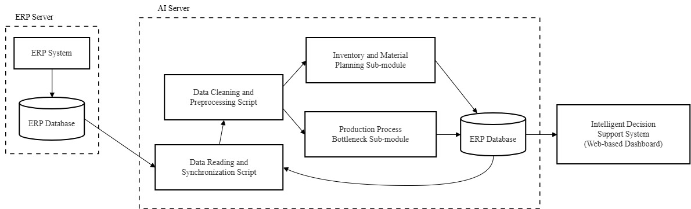
2.1 Data Acquisition, Cleaning, and Preprocessing
Fig. 1 Flowchart of the Intelligent Decision Support System
To ensure the stability of model training, this study implements a data cleaning mechanism. First, the system automatically removes records containing missing values. It then performs a preliminary screening based on material type, retaining only materials related to part numbers and production activities. To address the issue of low-frequency samples, this study uses product name and specification as key values and excludes materials with fewer than three observations, thereby preserving more representative samples. Finally, for the historical lead-time distribution of each material, the interquartile range (IQR) method is adopted, with 1.5 times the IQR defined as the valid range, in order to eliminate outliers caused by human recording errors or extreme disturbances.
For skewed continuous numerical features, such as purchase quantity and inbound lead time including holidays, this study applies the Yeo-Johnson transformation for de-skewing and standardization. For certain variables with pronounced right-skewed distributions, logarithmic transformation is used for scaling. Finally, all features are standardized in a unified manner to reduce the influence of differing scales on model training.
2.2 The Inventory and Material Planning Sub-module alongside the Production Process Bottleneck Sub-module
In the model input design, this study integrates both static and dynamic features for the inventory and material planning sub-module as well as the production process bottleneck sub-module. Static features mainly include part number, product name, specification, and other categorical fields. For long-string and high-cardinality categorical features, Feature Hashing is adopted for feature representation. Dynamic features include three-day and five-day moving averages, historical overall averages, variances, and other historical statistical measures in order to reflect short-term fluctuations and long-term performance. Numerical features cover lead-time moving averages, purchase quantity, supplier-estimated lead time, and statistical information derived from historical inbound distributions, including mean, standard deviation, maximum, minimum, and coefficient of variation. Categorical features include part number prefixes, complete material part numbers, segmented part-number features, and representations of combined product-name and specification strings. In addition, to reduce the memory burden caused by high-dimensional sparse features, this study stores the data in sparse
Table 1 Experimental Results of Material Lead-Time Prediction for Inventory and Material Requirements Planning.
Model\indicator | RMSE(Days) | MAE(Days) | MAPE
LightGBM | 2.5502 | 1.3937 | 10.20%
XGBoost | 2.5284 | 1.3956 | 10.26%
CatBoost | 2.6160 | 1.4944 | 10.86%
NN | 3.9108 | 2.4548 | 13.80%
matrices so as to improve model training and inference efficiency.
In the model output design, the output of the inventory and material planning sub-module is the estimated arrival or completion time in days, while the output of the production process bottleneck sub-module is process delay risk and related bottleneck analysis results.
2.3 Intelligent Decision Support Layer
Finally, the intelligent decision support system integrates the analytical results of the two sub-modules and presents them through two separate interfaces. The main interface provides manufacturing order information, material information, and risk alerts for bottleneck workstations. The secondary interface presents material demand and inventory levels, and flags materials that may delay production start due to shortages. The interfaces are connected to the database and allow users to manually modify information. When users adjust the actual production start date, the system recalculates the affected estimated delay days and synchronously updates the risk alerts.

3 Results
During the system implementation stage, this study integrated the analytical results of the two modules into a decision dashboard and used ERP data provided by a real factory in Taiwan as the basis for validation. However, due to NDA restrictions, the detailed content of the data is not disclosed in this paper. The research data mainly consist of manufacturing order files and material master information files. By analyzing the results of data cleaning, model prediction performance, and system implementation outcomes, this study examines the feasibility of applying the proposed approach in a real production environment.

In terms of system implementation, this study was developed on the basis of .NET Framework 4.8, with the user interface
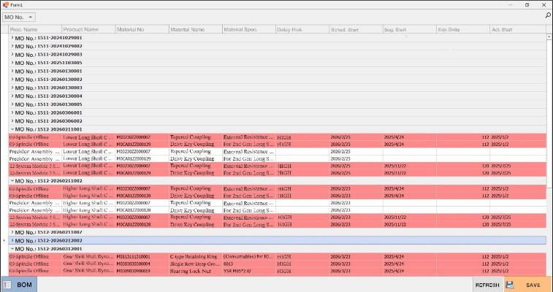
Fig. 2 Inventory and Material Planning System
built using WinForms and designed with the DevExpress v25.2 UI component library. The overall system is based on the MVC architecture, integrating the front-end interactive interface with the back-end database of manufacturing orders and process–material relationship data, in order to support the digital integration of production scheduling and supply chain management.

3.1 Predictive Performance of AI Models for Inventory and Material Requirements Planning
To determine the most suitable algorithm for the material lead-time prediction task, this study conducted benchmark testing using LightGBM, XGBoost, CatBoost, and neural networks, and the results are shown in Table 1. Overall, all models demonstrated strong predictive performance, indicating that after data cleaning and preprocessing, the data quality was relatively good and the feature signals were more distinct, enabling the models to effectively learn the variation trends in material lead times. A further comparison of the performance metrics shows that XGBoost achieved better performance in terms of the coefficient of determination (R²), and its validation curve was relatively stable. In contrast, although LightGBM performed slightly better in MAE and MAPE, it entered a convergence plateau at an earlier stage. After comprehensively considering the various error metrics and convergence stability, this study ultimately selected XGBoost as the core model for material lead-time prediction..

3.1 Predictive Performance of AI Models for Inventory and Material Requirements Planning
The inventory and material planning interface, as shown in Fig. 2, presents the core decision-making information for manufacturing orders, including the manufacturing order number, product name, scheduled start date, model-predicted recommended start date, actual start date, and delay risk assessment. The system performs logical evaluation based on the recommended start date and the scheduled start date. If the recommended start date is later than the scheduled start date, the system automatically flags a delay risk and classifies it into high, medium, or low risk according to the estimated number of delayed days. For example, a delay of more than 10 days is classified as high risk, a delay between 5 and 10 days as medium risk, and a delay of fewer than 5 days as low risk. The default actual start date is set as the scheduled start date; however, when the user revises the actual start date, the database can be synchronously updated to the material
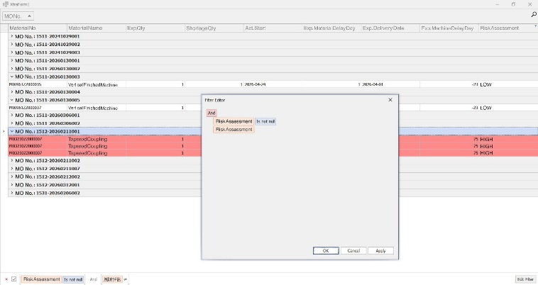
Fig. 3 Material Decision Support System
requirement list under that manufacturing order, thereby ensuring consistency between front-end operations and database information.
The material decision support system, shown in Fig. 3, serves as the secondary interface. It can receive the actual start date parameter passed from the main interface and, together with the rule base and inventory levels, perform calculations to provide recommendations on material procurement lead time, material requisition timing adjustments, and inbound delivery reminders. In addition, the system also provides filtering functions, allowing users to query delayed materials or materials whose actual start date exceeds a specified threshold. Through this dual-interface linkage design and customized data display functions, the system not only assists managers in handling production start scheduling, but also realizes the objective of schedule-driven material supply, effectively reducing the risk of production stoppages caused by material shortages.

4 Conclusion
This study develops a data-driven intelligent decision support system for smart-factory material planning and production process optimization, and validates it using real ERP data provided by a partner company. The results show that, through Feature Hashing, dynamic feature construction, and the XGBoost prediction model, the system can effectively support material lead-time prediction and delay-risk assessment. The analytical results are further integrated into a decision dashboard to provide material requisition reminders and scheduling support information. Future research may further incorporate incremental learning and equipment sensor data to enhance the model’s updating capability and the overall completeness of system applications.
5 References
Conference Paper
[1] H. Abbasimehr, M. Shabani, and M. Yousefi, "An optimized model using LSTM network for demand forecasting," Computers & Industrial Engineering, vol. 143, p. 106435, 2020.
[2] K. Douaioui, R. Oucheikh, O. Benmoussa, and C. Mabrouki, "Machine learning and deep learning models for demand forecasting in supply chain management: A critical review," Applied System Innovation, vol. 7, no. 5, p. 93, 2024.
[3] J. Feizabadi, "Machine learning demand forecasting and supply chain performance," International Journal of Logistics Research and Applications, vol. 25, no. 2, pp. 119-142, 2022.
[4] S. M. K. Sistla, G. Krishnamoorthy, J. Jeyaraman, and B. K. Konidena, "Machine learning for demand forecasting in manufacturing," International Journal for Multidisciplinary Research (IJFMR), vol. 6, no. 1, 2024.
[5] M. Subramaniyan, A. Skoogh, H. Salomonsson, P. Bangalore, M. Gopalakrishnan, and M. A. Sheikh, "Data-driven algorithm for throughput bottleneck analysis of production systems," Production & Manufacturing Research, vol. 6, no. 1, pp. 225-246, 201

